Vocabulary NOS

1. Pseudoscience:
2. Observation : the use of one or more senses to gather information and take note of what occurs.
3. Inference : a logical explanation of an observation that is drawn from prior knowledge or experience.
4. Hypothesis : a possible explanation about an observation that can be tested by scientific investigations.
5. Scientific Theory: an explanation of observations or events based on knowledge gained from many observations and investigations.
6. Scientific Law: describes a pattern or an event in nature that is always true.
7. Variable : any factor in an experiment that can have more than one value.
8. Dependent (Outcome) Variable: the factor being measured or observed during an experiment.
9. Independent (Test) Variable: the factor that you want to test, manipulate or change.
10. Constants : the factors in an experiment that remain the same. This provides reliability in the investigation.
**Control Variable: the “group” in an experiment that is not subjected to the test variable! It is not affected by the experiment.
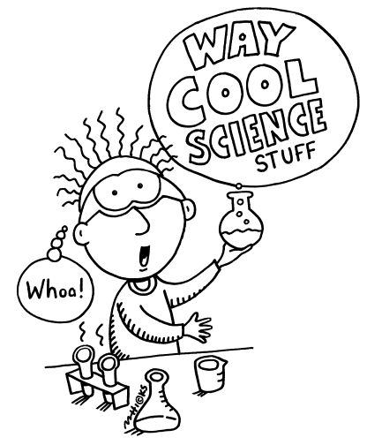

 | Roundhouse Diagram Instructions
1 | Steps:  First, draw a large circle and make ten pie pieces  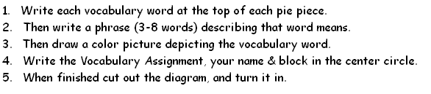
2 | Nature of Science Test 1

